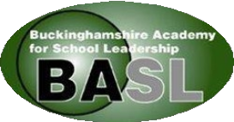
BASL MEMBERSHIP OFFER 2025/26
Access to 4 Seminars
£10 per delegate for member schools / a recording (if available)
£60 per delegate for non-member schools / a recording (if available)
Two Heads Are Better Than One.
Informal support from headteacher colleagues for no additional charge
2026 BASL Conference
Discounted delegate access to the annual two-day event
To be held at The Crown Plaza, Stratford Upon Avon, on 19 & 20 March 2026
Deputy Head and Senior Leaders Conference
Discounted delegate access to this one-day event
NEW Deputy Heads offer – more information to follow in September

First Step into Leadership
Up to 4 seminars for Middle and Senior Leaders who are new to leadership for no additional charge

For more information, please contact BASL@buckinghamshire.gov.uk
Membership Charges
New Headteacher 1st year in headship FREE
Schools with <150 £100 + VAT Schools with 151-250 £200 + VAT Schools with >251 £300 + VAT
Advice
Free telephone support from BASL Board Members
Celebration Event
End of Year Celebration Event for all Headteachers with keynote speaker

